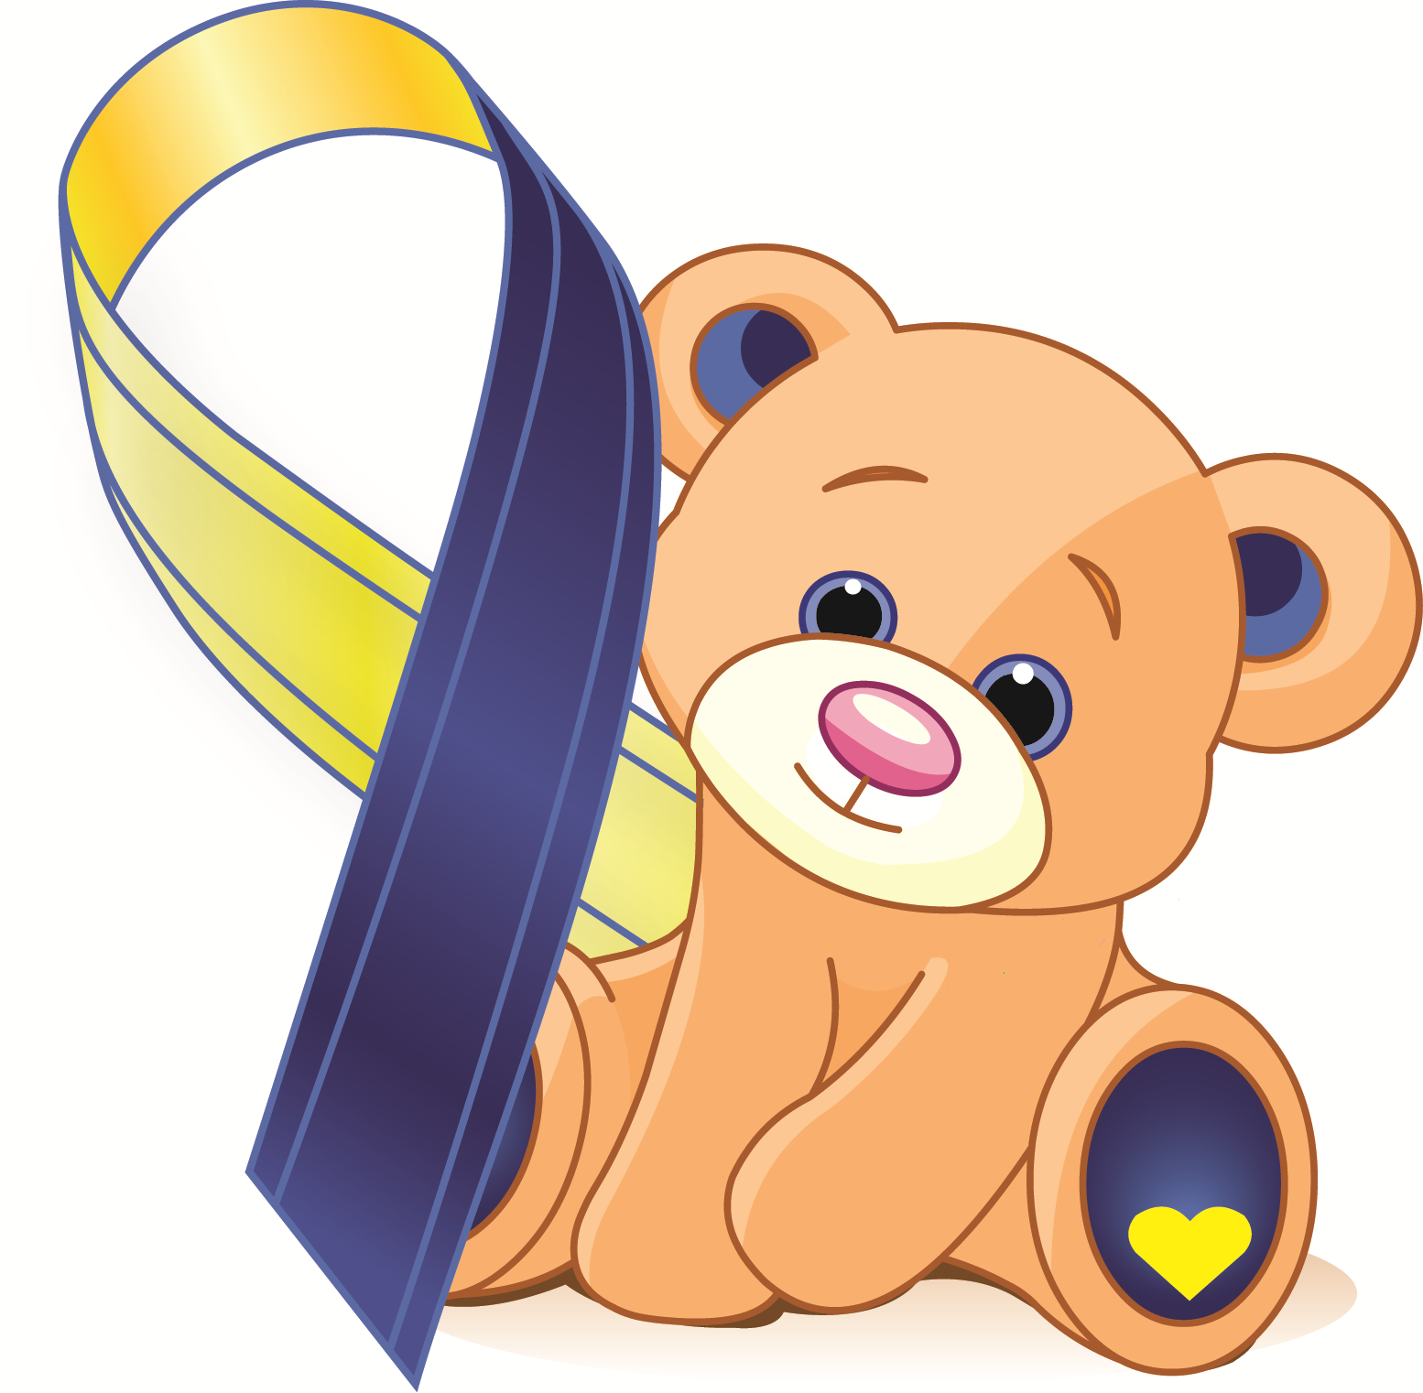
OMSLife and Dancing Eye Syndrome Support Trust

present

The Eleventh International Workshop on Opsoclonus Myoclonus Ataxia Syndrome
Clinical and Basic Science

Leonardo Royal Hotel Oxford, Godstow Rd, Wolvercote, Oxford OX2 8AL, United Kingdom
10th – 12th April 2025

THE WORKSHOP
This is the 11th International OMS workshop to be held at Leonardo Royal Hotel in Oxford. Formerly known as Dancing Eye Syndrome workshops, they are an opportunity to bring together clinicians and scientists with a special interest in the condition. Parents and patients contribute first -hand experience of the lives of children with OMS.
The organisation of the workshop is thanks to the dedication of the members of the OMS scientific steering committee.
The workshop is being sponsored jointly by The OMSLife Foundation and Dancing Eye Syndrome Support Trust.
Thank you to the Leonardo Royal Hotel for providing such a conducive venue for this kind of meeting.
Thank you to everyone who has given up their time to come and participate in this workshop.

www.dancingeyes.org.uk

www.omslifefoundation.org

Thursday 10th April

1600: Tea and Welcome

1630: Session 1: Updates, progress and initiatives
Chair: Ming Lim

Welcome:-

OMS History: with tribute to Marcel Kinsbourne
Andrea Klein

OMS introduction and summary of last workshop
Ming Lim

OMS Charter, membership and election: progress since last year
Ian Grummitt

Clinical Studies:-

Prognosis, treatment, and mechanisms in an international pediatric-onset opsoclonus myoclonus ataxia syndrome (POOMAS) study: an update
Mark Gorman

Opsoclonus Myoclonus Syndrome/​Dancing Eye Syndrome (OMS/​DES) in Children With and Without Neuroblastoma (NBpos and NBneg)Opsoclonus Myoclonus Syndrome/​Dancing Eye Syndrome (OMS/​DES) in Children With and Without Neuroblastoma (NBpos and NBneg)
Gudrun Schleiermacher

Adaptive trial designs in rare disorders
Gary Cutter

1930: Conference Dinner

Friday 11th April

0830: Session 2: Therapeutics

Chair: Mark Gorman

Vamorolone: Can it be a treatment for OMAS?

Tim Lotze & Ming Lim

Smorgasbord of challenging cases

Wendy Mitchell/ Cheryl Hemingway

1030: Coffee

1100: Session 3: Biomarkers
Chair: Wendy Mitchell

Detection of novel autoantibodies in children with OMS
Thais Armangue/Tory Johnson

"Investigation of Autoantibody Candidates in Patients with Opsoclonus Myoclonus Ataxia Syndrome Using Human Proteome Microarrays."
Taisuke Yamauchi

Abnormal eye tracking in OMAS: beyond diagnostics
Ann Yeh

Tumour immunobiology
Sally George
Mathias Fischer

1300: Lunch

1400: Session 4: Symptoms and OUTCOMES
Chair: Cheryl Hemingway

Sleep/irritability and chronic symptoms (OMSLife Registry)
Yasmin Khakoo & Scott Milligan

Update OMSLife patient reported registry
Scott Milligan

Whole Genome Sequencing and HLA typing in OMAS
Mark Gorman

Inaugural Findings on OMSLife Registry
Mark Gorman/Mike Michaelis

1600: Tea

1630: Session 5: Spectrum of OMAS: an international perspective
Chair: Kumaran Deiva

Neurodevelopmental outcomes following OMAS: An Indian perspective
Naveen Sankhyan

Infections associated OMAS: Do we need to approach differently?
Naveen Sankhyan

Clinical presentation and outcome of OMAS: A Brazilian perspective
Renata Paolilo

Clinical presentation and outcome of OMAS: A Japanese perspective
Taisuke Yamauchi

Pablove grant considerations
Naveen Viswanatha

1930: Conference Dinner

Saturday 12th April

0900: Session 6: Behavioural Issues and OMAS
Chair: Aaron Hauptman

Hannah Schofield (CHOP)

1230: Summing up session

1300: Lunch and farewell
Steering committee to meet over lunch

